SIMPLE WEATHER STATION WITH NODE MCU AND THINGSPEAK

Introduction

It is a environment monitoring sensor that measures relative humidity, and barometric pressure; stores data collected at some predetermined sampling interval, with date and time stamps, for later retrieval; introduces the use of packet radio modules for sending weather station data from one Arduino to another.

Why did we decide to make this project?

The main motto of making this project is to provide facility, either on land or sea, with instruments and equipment for measuring [atmospheric](https://en.wikipedia.org/wiki/Earth%27s_atmosphere) conditions to provide information for [weather forecasts](https://en.wikipedia.org/wiki/Weather_forecasting) and to study the [weather](https://en.wikipedia.org/wiki/Weather) and [climate](https://en.wikipedia.org/wiki/Climate) without Wi-Fi connection. The measurements taken include [atmospheric](https://en.wikipedia.org/wiki/Atmospheric_pressure) pressure and [humidity](https://en.wikipedia.org/wiki/Humidity).

Materials and methods

Components Required:

* Hardware:

|  |  |  |  |
| --- | --- | --- | --- |
| S. No | Name of Component | Picture | Description |
| 1. | Node MCU ESP8266 Breakout Board | C:\Users\HP\AppData\Local\Packages\Microsoft.Office.Desktop_8wekyb3d8bbwe\AC\INetCache\Content.MSO\2DFE3A1.tmp | Node MCU is an open source [IoT](https://en.wikipedia.org/wiki/Internet_of_Things) platform. It includes firmware which runs on the [ESP8266](https://en.wikipedia.org/wiki/ESP8266) [Wi-Fi](https://en.wikipedia.org/wiki/Wi-Fi) [SoC](https://en.wikipedia.org/wiki/System_on_a_chip) from Express, and hardware which is based on the ESP-12 module. The term "Node MCU" by default refers to the firmware rather than the development kits. |
| 2. | BMP180 | Image result for bmp 180 | The BMP180 consists of a piezo-resistive sensor, an analog to digital converter and a control unit  with E2PROM and a serial I2C interface. The BMP180 delivers the uncompensated value of pressure and temperature. The E2PROM has stored 176 bit of individual calibration data. This is used to compensate offset, temperature dependence and other parameters of the sensor.   * UP = pressure data (16 to 19 bit) * UT = temperature data (16 bit)   Technical Specs:   * Vin: 3 to 5VDC * Logic: 3 to 5V compliant * Pressure sensing range: 300-1100 hPa (9000m to -500m above sea level) * Up to 0.03hPa / 0.25m resolution-40 to +85°C operational range, +-2°C temperature accuracy * This board/chip uses I2C 7-bit address 0x77 |
| 3. | PCB Board |  |  |
| 4. | DHT11 Temperature & Humidity Sensor | C:\Users\HP\AppData\Local\Packages\Microsoft.Office.Desktop_8wekyb3d8bbwe\AC\INetCache\Content.MSO\C85E365E.tmp | * The DHT11 is a basic, ultra low-cost digital temperature and humidity sensor. * It uses a capacitive humidity sensor and a thermistor to measure the surrounding air, and spits out a digital signal on the data pin (no analog input pins needed). Its fairly simple to use, but requires careful timing to grab data. * The only real downside of this sensor is you can only get new data from it once every 2 seconds, so when using our library, sensor readings can be up to 2 seconds old.     Technical Specs:   * 3 to 5V power and I/O * Good for 0-50°C temperature readings ±2°C accuracy * Good for 20-80% humidity readings with 5% accuracy * 2.5 mA max current use during conversion (while requesting data) |
| 5. | Photoresistor | C:\Users\HP\AppData\Local\Packages\Microsoft.Office.Desktop_8wekyb3d8bbwe\AC\INetCache\Content.MSO\2715136D.tmp |  |
| 6. | Resistor 10k ohm | Resistor 10k ohm |  |
| 7. | Breadboard (generic) | C:\Users\HP\AppData\Local\Packages\Microsoft.Office.Desktop_8wekyb3d8bbwe\AC\INetCache\Content.MSO\6AD66503.tmp | A breadboard is a solderless device for temporary prototype with electronics and test circuit designs. Most electronic components in electronic circuits can be interconnected by inserting their leads or terminals into the holes and then making connections through wires where appropriate. |

* Software

1. [Thing Speak API](https://www.hackster.io/thingspeak/products/thingspeak-api)
2. Fritzing is an open-source hardware initiative that makes electronics accessible as a creative material for anyone. It is a software tool and a community website for Processing and Arduino, fostering a creative ecosystem that allows users to document their prototypes, share them with others, teach electronics in a classroom, and layout and manufacture professional pcbs.

Method

Mechanical modelling

Circuit designing

Supply power of 5V to node MCU .

1. DHT11 pin out /node MCU

Pin 1 ,pin 2 ,pin 3 and pin 4 are connected to 3.3V, D4, NC and ground respectively.

1. BMP180 with node MCU

Vin , ground ,SCL and SDA are connected to 3.3V,gnd,D2 and D1 respectively.

Software

1. Open Ardino IDE .
2. Copy the link.
3. Tools- Ardino ESP8266(Node MCU).
4. Tools – port.
5. Program AVRISP mk11
6. Compile
7. Upload
8. Error note check

Schematics

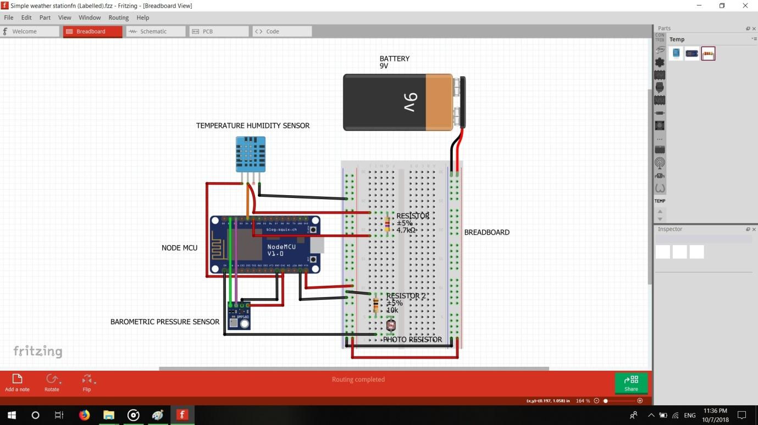

Cad Model

Future scope

Weather Monitoring Systems are used to monitor the continuously changing climatic conditions. The data gathered by such devices is used to forecast weather as well as keep a log of the environmental changes at a place. Such data is extremely useful in the study of earth and analysing the changing climatic and environmental conditions at a place. Further, the data and analytics so collected can be utilized in a variety of applications like agriculture, geology, mining and weather forecast. In this project, a simple weather monitoring system is designed which can monitor the temperature and humidity of a place.